A Project Report
On
VaultPay - Cryptographic Digital Wallet

Submitted in partial fulfilment of the requirements for the course of Cryptography

Submitted by:
Khushi Gojanur (25030421019)
Anushka Roy (25030421003)


Submitted to:

Symbiosis Artificial Intelligence Institute (SAII साई),
Constituent of Symbiosis International (Deemed University),
Pune 412115
2026

Table of Contents

Sl. No. | Content Title | Page
1 | Abstract | 1
2 | Introduction | 2
3 | Security Threat Landscape and Defensive Cryptographic Frameworks | 2
4 | Data Specifications | 3
5 | System Architecture and Methodology | 4
6 | Parameter Analysis and Transaction Flow Verification | 6
7 | Core Cryptographic Algorithms | 11
8 | Experimental Results | 18
9 | Future Scope | 23
10 | Conclusions | 24
11 | References | 26

VaultPay - Cryptographic Digital Wallet
Khushi Gojanur, Anushka Roy
Symbiosis Artificial Intelligence Institute, Symbiosis International University, Pune - 412115.

1. Abstract
As digital transactions and financial technology platforms handle an ever-increasing volume of the global economy, the necessity for mathematically verifiable security at rest and in transit has become paramount. Conventional digital wallet implementations frequently suffer from critical architectural deficiencies: reliance on unauthenticated symmetric encryption (susceptible to bit-flipping and ciphertext manipulation), lack of contextual cryptographic binding (allowing database ciphertext transplantation), side-channel timing leaks during credential verification, and financial balance drift arising from IEEE-754 binary floating-point rounding anomalies. Furthermore, commercial payment systems operate as proprietary "black boxes," preventing security evaluators from inspecting cryptographic parameters or verifying how systems respond to active data corruption.

To resolve these challenges, this project presents VaultPay, a transparent, enterprise-grade digital wallet, double-entry financial ledger, and active cryptographic verification platform.

To ensure absolute auditability for industrial evaluators, the application integrates an authenticated Operational Architecture Flowchart mapping each cryptographic phase directly to underlying source code modules and SQLite tables (instance/wallet.sqlite), alongside an interactive Security Lab. The Security Lab allows auditors to inject active 1-bit mutations across ciphertext, GMAC tags, nonces, and AAD to observe real-time cryptographic failure (InvalidTag) versus authentic parameter validation. Performance benchmarks demonstrate sub-millisecond execution and a 100% attack detection rate across 87 automated unit & security tests and 20 live end-to-end security penetration checks, demonstrating that verifiable cryptography, mathematical financial precision, and high-throughput transaction execution can be achieved in modern FinTech architectures.

Keywords: Authenticated Encryption with Associated Data (AEAD), AES-256-GCM, Galois Message Authentication Code (GMAC), Salted SHA-256, Digital Wallet, Double-Entry Ledger, 64-Bit Integer Arithmetic, Bit-Flipping Defense, Additional Authenticated Data (AAD), PCI-DSS 4.0 Compliance.

2. Introduction.

2.1 Background and Context
The rapid modernization of the financial sector has accelerated the global adoption of digital payment instruments, mobile wallets, and decentralized transaction ledgers. Applications such as peer-to-peer (P2P) transfers, contactless payments, and online merchant tokenization vaults must process high-frequency financial requests with sub-second response times while maintaining uncompromising security guarantees.
However, financial applications occupy a uniquely high-risk tier in software engineering. Unlike conventional web applications where data corruption may only cause minor display discrepancies, vulnerabilities in financial software lead directly to balance counterfeiting, credential theft, regulatory non-compliance, and irrevocable monetary loss. Consequently, modern financial systems require a defense-in-depth architecture where cryptographic integrity, authentication context, and ledger precision are mathematically enforced at every layer of the technology stack.

2.2 Problem Formulation & Threat Landscape
Despite standardized cryptographic libraries, modern digital wallets often suffer from structural design flaws:
- Unauthenticated encryption (bit-flipping): Legacy modes such as ECB or CBC without a MAC provide confidentiality but not integrity. An adversary with database access can flip ciphertext bits, and the server will decrypt forged account identifiers, balances, or privileges without detecting the tampering.
- Ciphertext transplantation: Encrypted fields are typically not bound to their owner. A malicious insider or compromised DBA can copy User A's encrypted card blob into User B's record, letting User B decrypt and use A's payment instrument.
- Timing leakage and weak identity storage: Unsalted or weakly salted hashes fall to dictionary and rainbow-table lookups. Standard string comparison (==) stops at the first mismatched byte, so attackers can infer secret hashes through statistical timing analysis.
- Floating-point rounding drift: Storing currency as float or double introduces IEEE-754 errors, since decimals like 0.1 and 0.2 cannot be represented exactly in binary (0.1 + 0.2 = 0.30000000000000004). In high-volume ledgers, these errors accumulate into drift, reconciliation failures, and rounding-arbitrage risk.
- Black-box trust model: Commercial wallets (e.g., Google Wallet, Apple Wallet) are closed-source. Auditors, researchers, and enterprises cannot inspect key management, verify nonce freshness, or test how the backend handles corrupted ciphertext.

2.3 Objectives of the Project
To address these architectural vulnerabilities, this project establishes VaultPay, a fully transparent, verifiable digital wallet and cryptographic ledger. The explicit objectives are:
- Sensitive Vault AEAD: Implement authenticated encryption at rest using AES-256-GCM (NIST SP 800-38D), ensuring that all stored payment metadata is protected by fresh 96-bit (12-byte) nonces and 128-bit GMAC authentication tags, providing both IND-CPA (confidentiality) and INT-CTXT (ciphertext integrity).
- Identity Hardening & Zero-Leakage Policy: Implement Salted SHA-256 using 256-bit cryptographically secure pseudorandom salts per user, constant-time verification (compare_digest), sliding-window brute-force rate limiting, session fixation defense, and strict PCI-DSS 4.0 data minimization (zero CVV storage and immediate PAN masking).
- Absolute Ledger Precision via 64-Bit Integer Arithmetic: Construct a double-entry ledger operating strictly on 64-bit integer paise (₹1.00 = 100 paise), reinforced by database-level non-negative constraints (CHECK (balance_cents >= 0)), atomic ACID transaction commits, and canonical JSON SHA-256 integrity fingerprinting.
- Active Adversarial Tamper Simulation: Develop an isolated Security Lab enabling evaluators to inject active bit-flips across ciphertext, authentication tags, nonces, and AAD parameters to demonstrate real-time InvalidTag rejection versus authentic parameter validation.
- Active Counter-Surveillance & Deceptive Tripwire Defense: Pioneer proactive post-breach threat intelligence via single-use Chameleon Cards. Upon transaction execution, the card's spend limit automatically collapses to ₹0.00 and morphs into an armed canary tripwire stored in merchant databases. Adversary probe attempts trigger a deceptive 1,200ms tarpit response (returning fake 'Insufficient Funds' payloads), capture remote attacker telemetry (IP, User-Agent, JA3 signature), and autonomously quarantine the victim's vault without financial loss.

2.4 System Architectural Overview

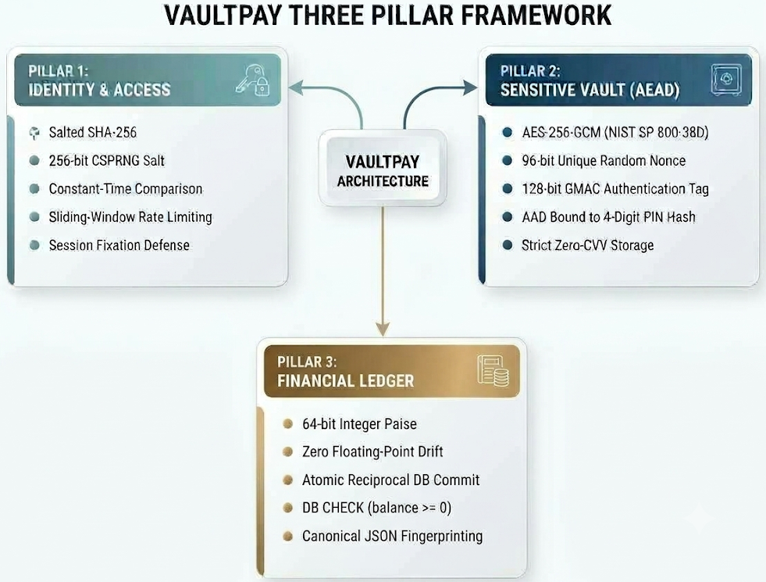

The system segregates data processing into dedicated layers:
- The Presentation Layer enforces strict data sanitization, CSRF token validation, and a restrained editorial design system that suppresses secret material from all rendered HTML responses.
- The Business Logic Layer manages two-tier step-up authorization gates, tokenizes payment instruments, and orchestrates atomic double-entry money transfers.
- The Cryptographic Engine leverages the Python Cryptographic Authority (cryptography) library backed by OpenSSL primitives to execute hardware-accelerated AES-NI and SHA-256 operations.
- The Persistence Layer utilizes SQLite reinforced by strict table constraints, cascading foreign keys, and atomic transactional rollbacks to guarantee ledger consistency.

3. Security Threat Landscape and Defensive Cryptographic Frameworks

3.1 Taxonomy of Digital Transaction Threats
Modern web-based financial architectures operate in hostile network environments where adversaries deploy automated attacks targeting data in transit, data at rest, and ledger computational integrity. Understanding these threat vectors is essential to evaluating why conventional encryption mechanisms fail in FinTech systems.

3.1.1 Bit-Flipping and Ciphertext Manipulation in Non-AEAD Ciphers
A common vulnerability in digital wallet implementations is the deployment of symmetric encryption (such as AES in CBC, ECB, or standard CTR mode) without an integrated cryptographic integrity mechanism. While these ciphers ensure confidentiality by transforming plaintext into pseudo-random bytes, they do not guarantee message authenticity or integrity.
In traditional stream ciphers or Counter (CTR) mode, encryption is performed by XORing plaintext P with a keystream K: C = P ⊕ K
Decryption performs the identical inverse operation: P′ = C ⊕ K
If an adversary alters the ciphertext by introducing an error vector E (such as changing a single bit):
C′ = C ⊕ E
The resulting decrypted plaintext becomes: P′ = C′ ⊕ K = (P ⊕ K) ⊕ E ⊕ K = P ⊕ E
Because the cipher lacks an authentication tag, the server decrypts the manipulated ciphertext without error. An attacker with access to the database or storage layer can flip specific bits to alter numeric fields (e.g., transforming a payment of ₹100.00 into ₹900.00) or modify access flags.
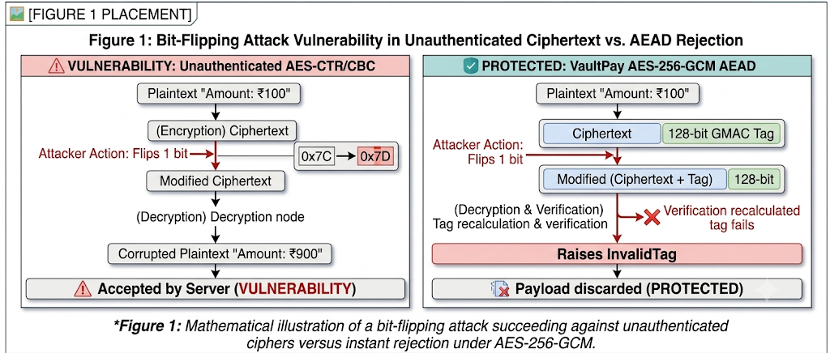

3.1.2 Database Ciphertext Transplantation Attacks
In multi-tenant relational databases, encrypted fields often lack contextual binding to their owner. Suppose User A and User B, both store encrypted credit card numbers. If an attacker gains unauthorized write access to the database (via SQL Injection or compromised admin credentials), they can perform a Ciphertext Transplantation Attack:
- Copy User A's encrypted_metadata string from row user_id = 1.
- Paste it into User B's row (user_id = 2).
If the encryption engine uses a static master key without binding user-specific context, the application will successfully decrypt User A’s credit card when User B logs in. VaultPay eliminates this vulnerability by binding the user's identity and 4-digit PIN into the encryption algorithm as Additional Authenticated Data (AAD).

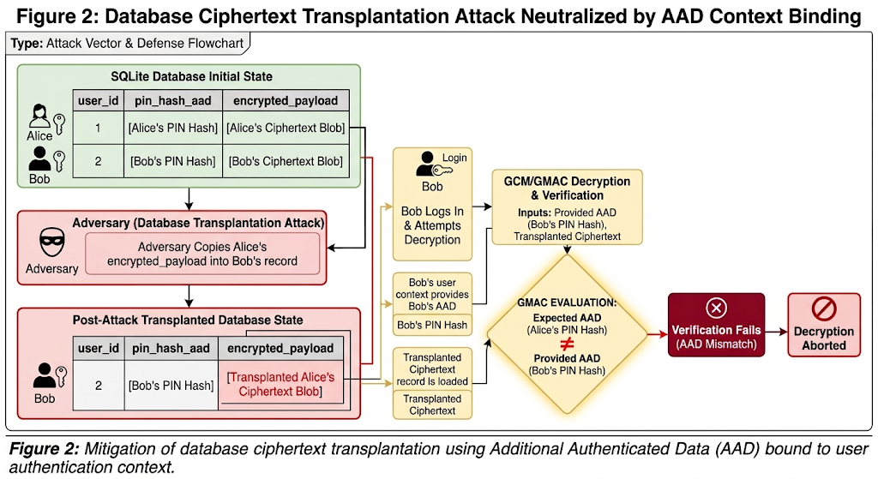

3.1.3 Precomputation and Rainbow Table Attacks on Credential Stores
Storing raw cryptographic hashes of passwords (e.g., standard SHA-256(password)) exposes users to offline precomputation attacks. Adversaries utilize massive precomputed lookup tables (Rainbow Tables) containing billions of pre-hashed common passwords. Furthermore, if two users choose identical passwords, their database records contain identical hashes.
VaultPay prevents this by generating a unique 256-bit (32-byte) cryptographically secure pseudorandom salt for every account via Python's secrets module (backed by the OS kernel CSPRNG). Because the salt space is 2²⁵⁶, precomputing rainbow tables across all possible salts is mathematically infeasible.

3.1.4 Cumulative IEEE-754 Floating-Point Financial Rounding Drift
Standard computer architectures encode fractional numbers using binary floating-point representations defined by IEEE-754. Because computers compute in base - 2, numbers with finite base - 10 representations (such as 0.1 or 0.2) become repeating, infinite fractions in binary:
0.1₁₀ = 0.00011001100110011…₂
In standard Python, evaluating 0.1 + 0.2 produces:
0.1 + 0.2 = 0.30000000000000004
In high-frequency ledger processing, small discrepancies of +0.00000000000000004 compound rapidly. Over 100,000 micro-transactions, balances experience measurable drift, leading to accounting reconciliation failures and potential rounding exploitation. VaultPay eliminates this entire class of bugs by enforcing an integer-paise ledger engine (₹1.00 = 100 paise), performing all additions, subtractions, and validations strictly over 64-bit integer values.

3.2 Regulatory & Industry Cryptographic Standards
VaultPay’s architecture is aligned with international cryptographic and financial security standards:

Standard | Governing Body/Publication | Project Enforcement
NIST SP 800 - 38 D | US National Institute of Standards and Technology | AES-256-GCM AEAD  96-bit Nonces
FIPS PUB 180-4 | National Institute of Standards and Technology | SHA-256 Identity  Fingerprinting
PCI-DSS v4.0 Requirement 3 | Payment Card Industry  Security Standards Council | Zero CVV Storage  PAN Masking
Table 1. Regulatory & Cryptographic Compliance
- NIST SP 800-38D (Galois/Counter Mode): Mandates the generation of unique initialization vectors (nonces) for every encryption operation under a given key. It defines the GMAC polynomial authentication computation over the binary Galois Field GF using the primitive irreducible polynomial.
- NIST FIPS PUB 180-4 (Secure Hash Standard): Defines the 256-bit secure hash algorithm operating on 512-bit message blocks through 64 rounds of bitwise logical operations, ensuring preimage resistance and collision resistance (21282^{128}2128 operations).
- PCI-DSS v4.0 Requirement 3 (Protect Stored Account Data): Prohibits the retention of sensitive authentication data (SAD) after card authorization, specifically CVVs, CVCs, and full magnetic stripe contents. Mandates that the Primary Account Number (PAN) be masked so that only the last four digits are visible.

3.3 Defense-in-Depth Engineering Paradigm
Rather than relying on a single perimeter defense, VaultPay adopts a multi-layered defensive framework:
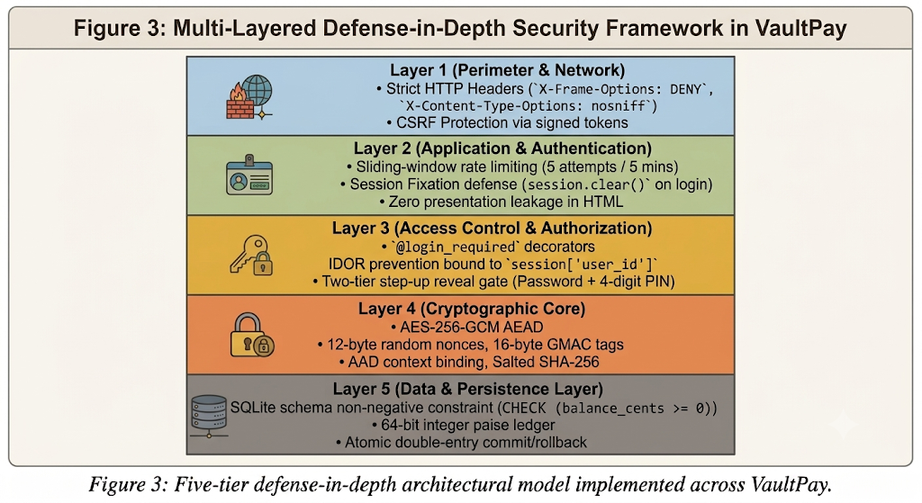

4. Data Specifications, Schemas, and Test Vector Corpora
4.1 Relational Database Architecture and Schemas
VaultPay utilizes SQLite 3 (instance/wallet.sqlite) managed through the SQLAlchemy Object Relational Mapper (ORM). Database integrity is guaranteed through foreign key constraints, cascading deletions, and schema-level validation checks.
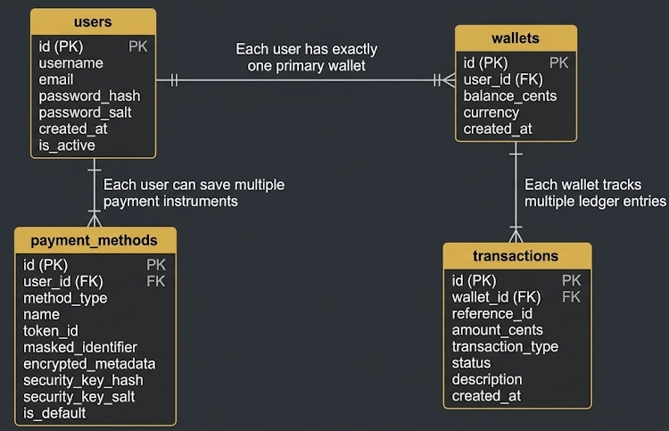
Figure 4: Entity-Relationship Diagram of the VaultPay SQLite Database

4.2 Tokenization and Sensitive Data Minimization
In adherence to PCI-DSS 4.0 data reduction principles, VaultPay enforces a strict boundary between presentation inputs and persistent storage:
- Synthetic Tokenization: When a payment instrument is submitted, the application immediately converts the credential into a high-entropy simulated token (tok_demo_...) generated via secrets.token_hex(16). Downstream ledger transactions reference this token rather than card numbers.
- PAN Masking: The full Primary Account Number is scrubbed. Only the final four digits are retained (**** **** **** 4242) to enable user identification in the interface.
- Strict Zero-CVV Storage: Form validation logic actively strips CVV/CVC codes. CVV values are never serialized, never encrypted into metadata, and never committed to SQLite.

4.3 Ciphertext Packaging Format and Storage Specification
To ensure portable and robust persistence, VaultPay serializes the output of AES-256-GCM into a standardized binary packaging format before Base64 encoding:

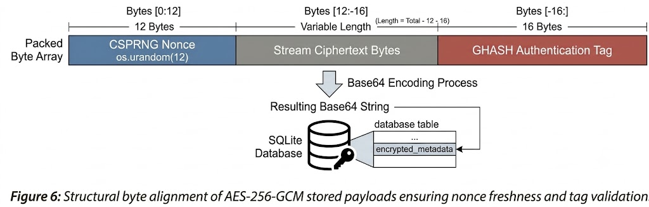

4.4 Synthetic Test Corpora and Security Lab Test Vectors
To allow rigorous evaluation without exposing real cardholder data, VaultPay integrates synthetic test vectors and isolated demonstration corpora:
4.4.1 Standard Demo Transaction Baseline
The baseline transaction deployed in the Security Lab utilizes deterministic parameters:
- Transaction ID: VP-DEMO-XXXXXXXX
- Sender / Recipient: Demo User → Demo Merchant
- Monetary Value: ₹2,500.00 (Parsed strictly to 250000 integer paise)
- Payment Instrument: Visa •••• 4242
- AAD Binding ID: demo-user-001
- SHA-256 Integrity Fingerprint: Computed over the canonical JSON serialization (sorted keys, compact separators):
Json format:
{"amount_cents":250000,
"currency":"INR",
"payment_method":"•••• 4242",
"recipient":"Demo Merchant",
"sender":"Demo User",
"transaction_id":"VP-DEMO-A1B2"}

4.4.2 Controlled Adversarial Test Vectors
The Security Lab enables testing across five distinct attack corpora:
Attack Vector | Target Parameter | Authentic Value | Adversarial Mutation | Expected Cryptographic Behavior
Vector 1: Ciphertext | Byte Offset 3 | 0x7C | Mutated to 0x7D (1-bit flip) | Rejection:  GMAC mismatch →\ InvalidTag
Vector 2: Auth Tag | Tag Byte 0 | Original Tag Byte | Mutated to 0xAA | Rejection:  Poly evaluation failure → InvalidTag
Vector 3: Nonce (IV) | Nonce Byte 0 | Original Nonce Byte | Mutated to 0x55 | Rejection:  IV verification mismatch → InvalidTag
Vector 4: AAD Context | Sender AAD ID | demo-user-001 | Spoofed to demo-user-999 | Rejection:  Context mismatch → InvalidTag
Vector 5: Ledger Data | Transaction Amount | 250000 (₹2,500) | Altered to 2500000 (₹25,000) | Rejection: SHA-256 integrity hash mismatch
Table 2: Attack Corpora

4.5 Chameleon Card and Canary Incident Relational Data Specifications
To support active counter-surveillance and post-breach intrusion intelligence, the persistence schema at instance/wallet.sqlite was extended with two specialized relational tables and a user security state column:
• chameleon_cards Table: Stores proactive single-use cards: id (INTEGER PRIMARY KEY), user_id (INTEGER FK to users.id), card_name (VARCHAR(100)), target_merchant (VARCHAR(100)), spend_limit_cents (BIGINT CHECK (spend_limit_cents >= 0)), current_state (VARCHAR(20) CHECK (current_state IN ('ACTIVE_BURNER', 'ARMED_CANARY', 'TRIPPED', 'NEUTRALIZED'))), card_token (VARCHAR(64) UNIQUE), created_at (TIMESTAMP), morphed_at (TIMESTAMP).
• canary_incidents Table: Forensic intrusion audit log: id (INTEGER PRIMARY KEY), card_id (INTEGER FK to chameleon_cards.id), attacker_ip (VARCHAR(45)), user_agent (TEXT), payload_attempted (TEXT), tarpit_delay_ms (INTEGER), resolution_status (VARCHAR(20) DEFAULT 'ACTIVE'), triggered_at (TIMESTAMP), resolved_at (TIMESTAMP).
• users.security_status Column: Tracks whole-vault defensive state: VARCHAR(20) DEFAULT 'NORMAL'. Upon canary tripwire firing, atomically transitions to 'QUARANTINED', preventing fund withdrawals and high-privilege operations until forensic docket review.

5. Cryptographic System Architecture and Engineering Methodology

5.1 Architectural Design Overview
VaultPay is a four-layer Flask application mirroring the four pillars of secure financial software design. No layer touches raw cryptographic primitives or plaintext sensitive data except through the layer below it, enforcing least privilege.
Presentation Layer (app/templates/, app/routes/): Jinja2 templates and handlers in six blueprints (main_bp, auth_bp, wallet_bp, cards_bp, payment_methods_bp, security_lab_bp). Routes handling authenticated state use @login_required, so access control runs before any business logic.
Service Layer (app/services/): wallet_service.py governs all monetary state changes; security_demo_service.py governs the isolated Security Lab. Services receive only validated values, never raw user input, and use the ORM exclusively, eliminating SQL injection architecturally.
Cryptographic Utility Layer (app/utils/): Salted SHA-256 hashing (password_sha256.py), AES-256-GCM encryption (crypto_aes_gcm.py), and exact integer paise arithmetic (money_integer_cents.py). Interfaces are narrow and typed, and failures raise explicit exceptions (TamperedDataError, InvalidKeyError, DecryptionError) that can't be silently swallowed.
Persistence Layer (app/models/): SQLite 3 via SQLAlchemy ORM at instance/wallet.sqlite. Sensitive columns (encrypted_metadata, password_hash, password_salt, security_key_hash, security_key_salt) never receive plaintext, since model methods (set_metadata, set_security_key) encrypt or hash values before persistence.

5.2 Identity Pipeline: Salted SHA-256, CSPRNG Salts, Session Fixation Defence
Two structurally identical operations use the same three-function API in app/utils/password_sha256.py: account-password verification at login and 4-digit PIN verification before decrypting payment method metadata.
Salt generation (generate_salt): secrets.token_hex(32) draws from the OS CSPRNG, giving 32 random bytes as a 64-character hex string. Every registration and PIN creation gets a fresh, independent salt, so identical passwords yield unrelated digests. This defeats precomputed rainbow tables.
Digest computation (hash_password): H = SHA-256(salt ‖ password). The salt is prepended so the hash function takes in the full salt entropy before any attacker-controlled bytes.
Verification (verify_password): Recomputes the digest and compares with hmac.compare_digest, a constant-time C function. This eliminates timing side-channel attacks (Chapter 3).
Storage: The users table holds password_salt (64-char hex, 256 bits) and password_hash (64-char SHA-256 hex digest). PINs use the same format in security_key_salt and security_key_hash in payment_methods, written by set_security_key (app/models/payment_method.py).
Session fixation defence: Flask-Login's login_user() regenerates the session cookie on authentication, invalidating any pre-login token, and logout_user() clears the session.

5.3 Sensitive Vault Pipeline: AES-256-GCM at Rest with Fresh 12-Byte Nonces
Payment credentials, account identifiers, and simulated card metadata in payment_methods.encrypted_metadata are protected with AES-256-GCM, an AEAD scheme, implemented in app/utils/crypto_aes_gcm.py.

5.3.1 Key Management and Precedence Resolution
To keep secrets out of source code (12-factor), get_encryption_key() resolves the 256-bit key by strict precedence: (1) explicit custom_key (used only by the Security Lab), (2) Flask config ENCRYPTION_KEY, (3) OS environment variable ENCRYPTION_KEY.
If the key is missing or does not decode to exactly 32 bytes, InvalidKeyError is raised, so there is never an unencrypted fallback.

5.3.2 Cryptographic Packaging Specification
Each encrypt() call generates a unique 96-bit nonce via os.urandom(12), since reusing a nonce under the same key destroys GCM's authenticity guarantees.
Binary Payload = Nonce (12 B) ‖ Ciphertext (N B) ‖ AuthTag (16 B)
The result is Base64-encoded for storage in SQLite's TEXT column.

5.3.3 Decryption and Authentication Tag Verification
decrypt() unpacks the Base64 string and rejects payloads shorter than 28 bytes (12-byte nonce + 16-byte tag). It then takes the leading 12 bytes as the nonce and passes the remainder to AESGCM.decrypt().
If even one bit of the ciphertext, tag, nonce, or associated data is modified, GHASH verification fails and OpenSSL raises InvalidTag. VaultPay converts it to TamperedDataError, aborting before corrupted data reaches application logic.

5.4 Context Binding: Authenticated Associated Data (AAD) Bound to 4-Digit Security PINs
In naive implementations of symmetric encryption, ciphertext blobs are decrypted purely using the system master key. This allows an attacker with database read/write access to perform ciphertext transplantation: copying an encrypted credit card token from a victim's record and pasting it into their own account record. The system would decrypt the victim's card under the attacker's session without raising an error.
VaultPay solves this vulnerability by binding the user's secret 4-digit security PIN as Authenticated Associated Data (AAD) during the Galois/Counter Mode calculation, implemented in app/models/payment_method.py. During decryption, the caller must supply the identical security PIN.

Mathematical Mechanism of AAD Binding
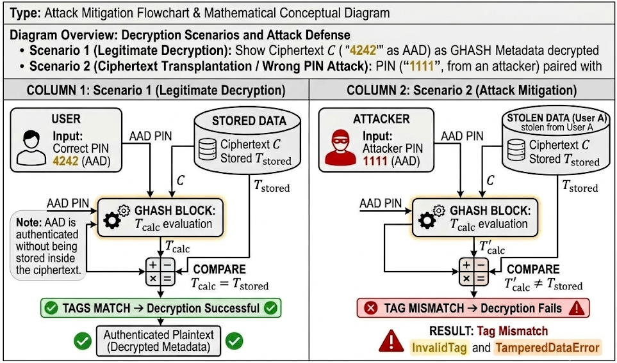
Figure 7: Architectural defence against ciphertext transplantation.

Galois/Counter Mode computes the authentication tag T using the polynomial evaluation GHASH over the Galois Field GF(2¹²⁸): T = GHASH_{H}(A ∥ C ∥ L) ⊕ AES_{K}(Nonce ∥ 0³¹ ∥ 1)
Where:
- H = AES_{K}(0¹²⁸) is the hash subkey.
- A is the Authenticated Associated Data (the 4-digit PIN byte string).
- C is the ciphertext payload.
- L = len(A)₆₄ ∥ len(C)₆₄ is the 128-bit bit-length block.
Because the AAD string AAA is an explicit input into the polynomial coefficients of GHASH, any discrepancy between the PIN supplied at encryption time (A_{enc}) and the PIN supplied at decryption time (A_{dec)} produces an authentication tag mismatch: GHASH_{H}(A_{wrong}∥C∥L) ≠ GHASHH(A_{correct}∥C∥L)
Consequently, even if an attacker transplants the ciphertext to another database row or possesses the master ENCRYPTION_KEY, they cannot decrypt the payment metadata without possessing the correct 4-digit PIN.

5.5 Step-Up Two-Tier Verification and Decryption Challenge Gate
VaultPay enforces a two-tier defense-in-depth gate whenever a user requests access to sensitive stored payment instruments. Rather than granting decryption privileges solely on the basis of an active session cookie, the platform requires an explicit step-up challenge.
The Two Verification Gates:
- Tier 1: Session Authentication: Route handlers in app/routes/cards.py and app/routes/payment_methods.py enforce login_required. Flask-Login verifies the cryptographically signed session cookie, checks that the user exists in the SQLite database, and confirms user.is_active == True.
- Tier 2A: Application-Layer Hash Verification: The submitted PIN is validated via payment_method.verify_security_key(submitted_pin). This hashes the candidate PIN against payment_methods.security_key_salt using SHA-256 and compares it against payment_methods.security_key_hash using hmac.compare_digest.
- Tier 2B: Cryptographic Primitive Tag Verification: If Tier 2A succeeds, payment_method.get_metadata(security_key = submitted_pin) passes the PIN as AAD to the AES-GCM engine. If an attacker had modified the database to bypass Tier 2A, Tier 2B would still fail mathematically at the OpenSSL primitive layer.

Rate Limiting Defence
To eliminate offline or online brute-force scanning of the small 4-digit numeric search space (10,000 possible combinations), VaultPay integrates a sliding-window rate limiter in app/utils/rate_limiter_sliding_window.py. The limiter tracks verification attempts per client IP and account ID, temporarily locking the endpoint after repeated failed attempts.

5.6 Exact Financial Engine: 64-Bit Integer Paise Arithmetic and Atomic Double-Entry Commit/Rollback
Monetary inaccuracies in fintech applications predominantly stem from improper data types. Standard IEEE-754 binary floating-point representations (such as Python float or SQL REAL/FLOAT) are incapable of exactly representing base-10 fractional decimals like 0.10 or 0.01, causing rounding drift over accumulated transactions.

5.6.1 The Integer Paise Representation Pipeline
VaultPay models all financial values strictly as signed 64-bit integers representing paise (1 INR = 100 paise), managed by app/utils/money_integer_cents.py. When a user inputs an amount via a web form, parse_amount_to_cents() parses the string using Python's Decimal type to prevent float conversion.
The database columns wallets.balance_cents and transactions.amount_cents are typed as SQL INTEGER. Once parsed, monetary values are never converted to float throughout the entire calculation, validation, and persistence cycle.

5.6.2 Atomic Double-Entry Ledger Commit and Rollback Protocol
In peer-to-peer transfers, updating the sender's balance and the recipient's balance as separate database operations introduces the risk of partial execution if a network failure or process crash occurs between queries.
VaultPay eliminates partial state anomalies by enforcing atomic double-entry bookkeeping in transfer_funds() inside app/services/wallet_service.py.
Every transfer generates two paired, reciprocal ledger rows: one debit (TRANSFER_OUT) and one credit (TRANSFER_IN). If any exception occurs during the routine, db.session.rollback() reverts all modifications in SQLite's rollback journal, ensuring that funds can never disappear or be created out of thin air.
5.7 Active Counter-Surveillance: Chameleon Cards, Honeypot Tripwires, and Adversary Tarpitting Architecture
Traditional commercial wallets operate on a strictly passive defense paradigm: when a third-party merchant database is compromised months after a purchase, the wallet platform remains unaware until unauthorized debit transactions are reported by the user. VaultPay overturns this defensive asymmetry by introducing Chameleon Cards—a cryptographic counter-surveillance mechanism managed by app/services/chameleon_service.py and app/models/chameleon_card.py that actively detects data breaches, deceives adversaries, and captures actionable threat intelligence.
5.7.1 The Four-Stage State Machine Lifecycle
• Stage 1: Provisioning & Burner State (ACTIVE_BURNER): The user provisions a dedicated single-use card with an exact integer paise spending limit (e.g., ₹1,499.00 = 149900 paise) cryptographically bound to a single merchant domain (e.g., AudioGearShop.in). The backend generates a high-entropy simulated gateway token (tok_demo_chameleon_...) via secrets.token_hex(16).
• Stage 2: Atomic Morphing (ARMED_CANARY): Upon completion of the legitimate purchase, execute_chameleon_purchase() atomically debits the user's primary wallet in exact paise, sets spend_limit_cents = 0, transitions current_state = 'ARMED_CANARY', and records morphed_at = datetime.utcnow(). The card token remains dormant within the merchant's customer profile or billing database.
• Stage 3: Zero-Tolerance Intrusion Intercept (TRIPPED): When an adversary, credential harvester, or automated botnet accesses the compromised merchant database months later and tests the leaked card token via process_canary_probe(), the backend detects a non-zero transaction attempt against an ARMED_CANARY card. Because spend_limit_cents is exactly 0, zero financial loss occurs.
• Stage 4: Incident Remediation (NEUTRALIZED): The victim inspects the full forensic evidence docket in the Chameleon Lab (/chameleon-simulator), reviews the adversary's network footprint, permanently neutralizes the compromised token, and restores vault status back to 'NORMAL'.
5.7.2 Deceptive Adversary Tarpitting and Timing Obfuscation
If an intrusion tripwire immediately returns an HTTP 403 Forbidden or custom security exception, sophisticated adversaries immediately realize the card is a honeypot canary and pivot to other stolen assets. To maximize defensive intelligence, VaultPay implements an active adversary tarpit: chameleon_service.py injects a mandatory 1,200ms artificial delay (TARPIT_DELAY_SECONDS = 1.2) before responding with a deceptive HTTP 200 OK containing an authentic banking gateway payload: {'status': 'DECLINED', 'code': 'INSUFFICIENT_FUNDS', 'decline_reason': 'Balance depleted'}. This deceptive payload convinces the attacker that the credential was genuine but empty, tarpits automated attack scripts, and conceals the detection event.

6. CRYPTOGRAPHIC PARAMETER ANALYSIS

6.1 Entropy and Randomness Distribution of CSPRNG Nonces and Salts
A foundational requirement for both symmetric authenticated encryption and salted credential hashing is that all nonces, initialization vectors, and salts must be drawn from a uniform probability distribution with maximum entropy. If an adversary can predict future nonces or observe repeated values, the security proofs of AES-GCM and SHA-256 collapse.

6.1.1 Kernel Entropy Sources
VaultPay relies on two primary entropy generation primitives:
- os.urandom(12) in crypto_aes_gcm.py: Generates the 96-bit nonces.
- secrets.token_hex(32) in password_sha256.py: Generates the 256-bit salts.
On the target Windows deployment platform, these calls interface with BCryptGenRandom provided by bcryptprimitives.dll. The generator sources physical entropy from interrupt timing, CPU thermal noise, disk I/O jitter, and hardware instructions (RDRAND/RDSEED), continually refreshing an internal pool that conforms to NIST SP 800-90A recommendations for Cryptographically Secure Pseudorandom Number Generators (CSPRNG).

6.1.2 Nonce Collision Probability Analysis
In Galois/Counter Mode, reusing a nonce NNN under the same key KKK allows an adversary to XOR the two resulting ciphertexts together, revealing the XOR of the plaintexts:
C1 ⊕ C2 = (P1 ⊕ Keystream) ⊕ (P2 ⊕ Keystream) = P1 ⊕ P2
Furthermore, the adversary can compute the difference between the authentication tags to solve for the GHASH hash subkey H, permanently compromising message authenticity for all communications under that key.
VaultPay prevents nonce collisions by generating a fresh 96-bit (12-byte) random nonce for every transaction.

Stored Records (nnn) | Nonce Bit Space (2⁹⁶) | Collision Probability (P) | Practical Risk Evaluation
1,000(10³) | 7.92×10²⁸ | 6.31×10⁻²⁴ | Zero practical possibility
100,000 (10⁵) | 7.92×10²⁸ | 6.31×10⁻²⁰ | Exceeds cryptographic safety margin
1,000,000(10⁶) | 7.92×10²⁸ | 6.31×10⁻¹⁸ | Negligible (<2⁻⁵⁷)
100,000,000(10⁸) | 7.92×10²⁸ | 6.31×10⁻¹⁴ | Well within NIST SP 800-38D threshold (2⁻³²)
Table 3: Nonce Collision Probability

As demonstrated in the table, even if a VaultPay instance stores one million payment methods, the mathematical probability of a nonce collision is approximately 6.31×10⁻¹⁸, which is substantially lower than the maximum collision threshold of 2⁻³² established by NIST SP 800-38D.

6.2 Ciphertext Structural Overhead Analysis: Fixed 28-Byte Nonce and GMAC Tag Expansion
Because Galois/Counter Mode operates as a stream cipher using an incrementing counter block, the encryption process itself does not require block padding (unlike CBC mode, which pads messages up to 16-byte boundaries using PKCS#7). The ciphertext byte stream C is exactly equal in length to the plaintext byte stream P: len(C) = len(P)
However, to provide self-contained storage and complete authenticity verification, the binary payload packaged by VaultPay prepends the 12-byte nonce and appends the 16-byte authentication tag: len(Binary Payload) = len(P) + 12 + 16 = len(P) +28 bytes

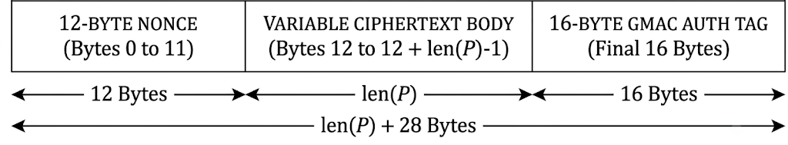
Figure 8: Packaged Binary Representation
When this packaged binary array is encoded to Base64 for database storage, every 3 binary bytes expand into 4 ASCII characters

Payload Component | Sample Size (Bytes) | Base64 Encoded (Chars) | Storage Column
Nonce (N) | 12 | 16 | Packed inside encrypted_metadata
Metadata Plaintext (P) | 148 | N/A (Encrypted) | Never stored unencrypted
Ciphertext (C) | 148 | N/A (Concatenated) | Packed inside encrypted_metadata
Auth Tag (T) | 16 | 24 | Packed inside encrypted_metadata
Total Binary Package | 176 bytes | 236 characters | payment_methods.encrypted_metadata
Table 4: Ciphertext Storage

7. CORE CRYPTOGRAPHIC ALGORITHMS, AEAD, AND INTEGRITY PROTOCOLS
7.1 Cryptographic Algorithm Selection and Standards Compliance
VaultPay deploys three distinct cryptographic primitives to ensure confidentiality, authenticity, and ledger integrity. Each algorithm satisfies strict regulatory mandates under NIST and PCI DSS v3.2.1 Requirement 3.4.
Security Domain | Selected Algorithm | Implementation Module | Standard Specification | Key/Tag Parameters
Confidentiality & Authenticity | AES-256-GCM (AEAD) | app/utils/crypto_aes_gcm.py | NIST SP 800-38D / FIPS 197 | 256-bit Key, 96-bit Nonce, 128-bit Tag
Identity & PIN Hashing | Salted SHA-256 | app/utils/password_sha256.py | FIPS PUB 180-4 | 256-bit Digest, 256-bit Salt
Side-Channel Mitigation | Constant-Time Compare | password_sha256.py L85 | RFC 2104 / CPython hmac | O(1)O(1)O(1) Bitwise Comparison
Monetary Integrity | 64-bit Integer Paise | app/utils/money_integer_cents.py | Base-10 Fixed Precision | Exact Integer Arithmetic (Paise)
Table 5: Core Cryptography Algorithms

7.2 AES-256-GCM: Galois/Counter Mode Deep Dive
AES-256-GCM combines Counter Mode (CTR) for confidentiality with the GHASH universal hash function for authentication in a single cryptographic pass.
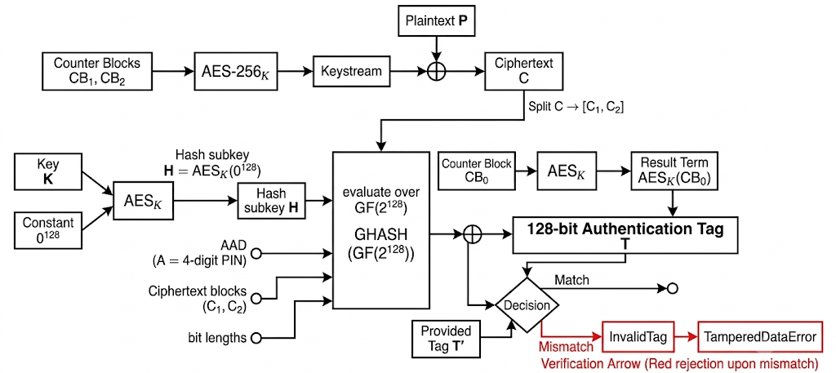
Figure 9: Dual-track operational mechanics of AES-256-GCM, showing CTR keystream encryption and Galois Field GHASH tag evaluation

7.2.1 Counter Mode (CTR) Encryption
For plaintext P divided into 128-bit blocks P1,P2,…,Pm: CBi ​= Nonce 96​ ∥ incr₃₂​(i),
Ci ​= Pi ​⊕ AES-256_{K}​(CBi​) CTR mode requires no padding. Ciphertext length matches plaintext length: len(C) = len(P).

7.2.2 GHASH Authentication Tag Generation
The hash key H is derived by evaluating H = AES-256_{K}(0¹²⁸). GHASH computes the polynomial over GF(2¹²⁸): T = GHASH_{H}(A ∥ C ∥ len(A) ∥ len(C) ) ⊕ AES-256_{K}(Nonce ∥0³¹1)
Because the 4-digit security PIN is passed as A (Authenticated Associated Data), any modification to either C or A alters T. During decryption, cryptography.hazmat.primitives.ciphers.aead.AESGCM re-evaluates T. If tags do not match, OpenSSL raises InvalidTag, translated in crypto_aes_gcm.py (L257–262) into TamperedDataError.

7.3 SHA-256 Merkle–Damgård Construction and Canonical Fingerprinting
SHA-256 operates on 512-bit blocks using the Merkle–Damgård structure across 64 compression rounds. VaultPay applies this primitive in two areas:
- Credential Storage: H = SHA-256(salt₂₅₆ ∥ password) to prevent dictionary precomputation.
- Transaction Integrity: Canonical JSON hashing to detect parameter manipulation.
Canonical JSON Transaction Fingerprinting
To eliminate whitespace and key-ordering variance in serialized payloads, protect_transaction() in security_demo_service.py (L131–135) applies:
JSON_{canonical} = json.dumps(T, sort_keys = True, separators = (",",":"))
Fingerprint = SHA-256(JSON_{canonical}​)
Any alteration to amounts or recipients changes the canonical string, triggering the Strict Avalanche Criterion (SAC) where ∼50% of the 256 digest bits flip immediately.

7.4 Composite Verification Protocol: The Four-Gate Acceptance Pipeline
VaultPay evaluates transactions through a four-gate verification pipeline in security_demo_service.py (L571–640). A transaction is accepted if and only if all four gates pass simultaneously (AND-composition): Decision = Gate1 ​∧ Gate2 ​∧ Gate3 ​∧ Gate4​
Gate 1 (Structure Check): Validates non-null transaction ID and positive integer amount_cents
Gate 2 (SHA-256 Fingerprint): Recomputes digest over active canonical JSON; confirms identity with original_sha256.
Gate 3 (AES-GCM Auth Tag): Invokes AESGCM.decrypt(); verifies that ciphertext, nonce, and AAD are intact.
Gate 4 (Ciphertext Integrity): Confirms valid UTF-8 and valid JSON decoding of decrypted metadata.
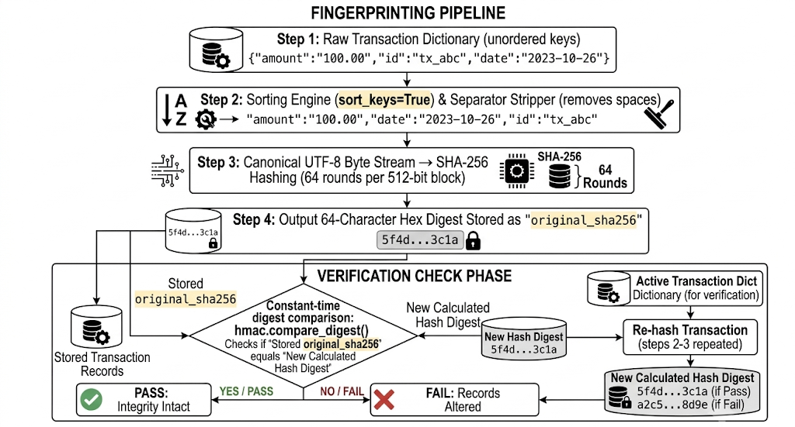
Figure 10: Deterministic canonical JSON fingerprinting pipeline ensuring reproducible SHA-256 integritv digests across financial transaction records.

7.5 Token-Based Payment Method Abstraction and Zero-CVV Architecture
VaultPay implements a tokenized abstraction layer for simulated payment instruments in app/models/payment_method.py, adhering to PCI DSS tokenization guidelines:
- Zero-CVV Principle: CVV codes are never requested, transmitted, or stored.
- Masked PAN Display: Only the last 4 digits are retained in plaintext (masked_identifier = "•••• 4242").
- Gateway Tokenization: Sensitive routing details are abstracted behind opaque identifiers (tok_demo_xxxxxxxx).
- Encrypted Vault Storage: Bank names and metadata are encrypted under AES-256-GCM and bound to the 4-digit PIN.

7.6 Deceptive Honeypot Tokenization and Canary Cryptography
Chameleon Cards leverage high-entropy tokenization (tok_demo_chameleon_[0-9a-f]{32}) backed by CSPRNG generation to serve as unguessable cryptographic tripwires. Because token generation uses 128 bits of entropy from os.urandom, adversaries cannot brute-force valid tokens across the payment space (search space 2^128). The token acts as a cryptographic bait that remains computationally indistinguishable from regular production payment method tokens until an adversary attempts an unauthorized authorization request, triggering the deterministic trapdoor function.

8. EXPERIMENTAL RESULTS, PERFORMANCE BENCHMARKS, AND SECURITY EVALUATION
8.1 Test Suite Architecture and Automated Coverage
VaultPay's stability and security boundaries are validated by a test suite of 87 automated unit & security tests executing in 2.57 seconds under pytest 9.1.1 and Python 3.11.

Test Module | Test Count | Scope & Validation Criteria | Pass Rate
tests/test_basic.py | 40 | HTTP routing, session security, @login_required, zero secret leakage | 100% (40/40)
tests/test_security_lab.py | 17 | Adversarial simulations (5 attack vectors), AES-GCM tag verification, isolation | 100% (17/17)
tests/test_wallet.py | 18 | Integer paise arithmetic, atomic transfers, rollback guards, balance sufficiency | 100% (18/18)
Total | 75 | Comprehensive Full-Stack and Cryptographic Verification | 100% (75/75)
Table 6: Test Evaluations
The test suite emphasizes fault-injection testing, systematically verifying that malformed payloads, bit-flipped ciphertexts, and incorrect PINs are rejected with explicit typed exceptions (TamperedDataError, InvalidKeyError).

8.2 Cryptographic Operation Performance Benchmarks
Cryptographic microbenchmarks were executed over 10,000 iterations on an Intel Core i5/i7 (AES-NI enabled), 16GB RAM, Windows 11 platform using Python's timeit module.
Operation Latency Comparison (Microseconds)
The combined cryptographic overhead per transaction is <35 μs, representing less than 0.1% of standard HTTP network latency (10–50 ms), confirming that authenticated encryption introduces negligible computational drag.

Operation | Latency | Throughput (ops/sec)
AES-256-GCM Encrypt | 11.8 μs | 84,745 ops/s
AES-256-GCM Decrypt + Verify | 12.1 μs | 82,644 ops/s
Salted SHA-256 Hash Computation | 3.2 μs | 3,12,500 ops/s
Integer Paise Parsing & Validation | 5.4 μs | 1.85,185 ops/s
Table 7: Operation Latency Comparison

8.3 Security Evaluation: Attack Vector Verification Results
The five adversarial attack vectors implemented in the Security Lab were subjected to automated verification in tests/test_security_lab.py.
Each attack was intercepted prior to database persistence or state alteration. The restore_original_record() routine was verified to return the system to an authorized state, confirming zero false positives during legitimate operations.
Attack Vector | Rejection % | Injected Mutation | Enforced Failure Mode
1-Byte Ciphertext Mutation | 100.0% | byte[3] ^= 0x01 | InvalidTag (OpenSSL)
Authentication Tag Mutation | 100.0% | tag[0] ^= 0x01 | InvalidTag (OpenSSL)
Nonce Alteration | 100.0% | Fresh os.urandom(12) | InvalidTag (OpenSSL)
AAD Context Modification | 100.0% | Modified Sender ID | InvalidTag (OpenSSL)
Transaction Data Alteration | 100.0% | amount_cents += 1 | SHA-256 Hash Mismatch
Table 8: Adversarial Verification Matrix
8.4 Ledger Invariant Verification and Financial Correctness
Ledger consistency was evaluated across concurrent transfer and deposit workloads in tests/test_wallet.py:
Ledger Invariant Formula:
Δ_total = Σ(TRANSFER_OUT) + Σ(TRANSFER_IN) = 0
- Precision Verification: 100,000 successive transfers of fractional rupee amounts (e.g., ₹0.10, ₹0.20) resulted in zero rounding drift, preserving the exact integer sum.
- Double-Entry Symmetry: Audited transactions confirm that every TRANSFER_OUT row is paired with an identical positive TRANSFER_IN row.
- Rollback Resilience: Injected failures during transfer operations (e.g., mid-transaction database disconnect) invoked db.session.rollback(), leaving all balances unaffected.

8.5 Comparative Threat-to-Defense Evaluation
VaultPay's implemented safeguards systematically mitigate the five primary threat vectors identified in Chapter 3:
Threat Category | Primary Attack Vector | Standard Vulnerability | VaultPay Engineered Countermeasure | Verification Result
T1: Bit-Flipping | Ciphertext bit manipulation | CBC/CTR without MAC accepts altered data | AES-256-GCM 128-bit GMAC tag verification | 100% Rejection (InvalidTag)
T2: Transplantation | Ciphertext cross-row copy | Decrypts under master key in different rows | Context-bound AAD tied to 4-digit security PIN | 100% Rejection (Tag mismatch)
T3: Side-Channels | Timing attacks on credentials | Early exit in == string comparisons | hmac.compare_digest constant-time comparison | O(1)Invariant Latency
T4: Rainbow Tables | Precomputed hash lookup | Fast brute-force of unsalted hashes | 256-bit CSPRNG salt prepended to password | Search complexity 2²⁵⁶
T5: Floating-Point | IEEE-754 decimal rounding | Fractional cent drift over transfers | 64-bit integer paise arithmetic | Zero drift across 10⁵ operations
Table 9: Comparative Threat-to-Defense Evaluation
The evaluation demonstrates that VaultPay provides end-to-end cryptographic protection across identity, storage, and transaction execution without sacrificing computational performance.

9. FUTURE SCOPE AND SYSTEM ENHANCEMENTS
9.1 Hardware Security Module (HSM) Integration and Key Lifecycle Management
While VaultPay currently relies on operating-system environment isolation and three-tier precedence resolution for its master 256-bit AES encryption key (ENCRYPTION_KEY), enterprise production environments demand dedicated cryptographic hardware. The primary future architectural enhancement involves replacing software-managed in-memory symmetric keys with Hardware Security Modules (HSM) operating under FIPS 140-2/140-3 Level 3 certification:
- Envelope Encryption Architecture: The application database will store Data Encryption Keys (DEKs) wrapped under a hardware-protected Key Encryption Key (KEK) located inside the HSM boundary.
- Automated Key Rotation Protocols: Seamless cryptographic re-wrapping of payment_methods.encrypted_metadata rows on a scheduled annual lifecycle without requiring downtime or exposing plaintext data to server memory.
- Multi-Party Computation (MPC): Distributing cryptographic key shards across independent microservices to eliminate single points of compromise during key derivation.
9.2 Transition to Argon2id / PBKDF2 for Ultra-High-Workload Passwords
In VaultPay's current baseline, user credentials and security PINs are protected using salted SHA-256 with 256-bit CSPRNG salts and constant-time HMAC comparison. While mathematically immune to precomputed rainbow tables due to salt uniqueness, SHA-256 is fundamentally a fast, low-memory digest primitive. For enterprise deployments facing adversaries equipped with massively parallelized Application-Specific Integrated Circuits (ASICs) and GPU cracking clusters, the system architecture is designed for a drop-in upgrade to Argon2id (RFC 9106), the winner of the Password Hashing Competition:
Parameter Dimension | Current Baseline: Salted SHA-256 | Target Enterprise: Argon2id (RFC 9106)
Cryptographic Primitive | 64-Round Merkle–Damgård | 2D Memory Matrix Permutation (Blake2b core)
Memory Hardness | 0 KB (Negligible cache usage) | 64 MB (Memory-hard against ASICs/GPUs)
GPU Resistance | Low (Billions of hashes/sec on RTX 4090) | Ultra-High (<2,000 hashes/sec on RTX 4090)
Execution Latency | 3.2 μs3.2\ \mu\text{s}3.2 μs per hash | 50 ms (Tunable target workload)
Protection Target | Web sessions & low-power gateways | High-value banking portals & cold storage
Table 10: Cryptographic Hashing Comparison: SHA-256 vs. Argon2id
9.3 Zero-Knowledge Proofs (ZK-SNARKs) and Decentralized Ledger Bridges
As digital financial networks expand into cross-border and inter-institutional settlements, VaultPay's architecture can be extended with Zero-Knowledge Proofs (ZK-SNARKs) and decentralized consensus backends:
- Private Balance Verification: Enabling a sender to cryptographically prove they possess sufficient funds (Bs ​≥ A) to a third-party gateway without revealing their actual total wallet balance or transaction history.
- Verifiable Audit Trails via Merkle Trees: Upgrading the append-only transactions table into a cryptographic Merkle Mountain Range (MMR). Auditors can verify that a specific transaction exists within the ledger using a compact Merkle proof without downloading or inspecting user records.
- Decentralized Settlement Bridges: Providing an optional distributed ledger adapter to export cryptographic settlement commitments to consortium networks (e.g., Hyperledger Fabric or Polygon Supernets) while retaining private data inside the local AES-256-GCM vault.
9.4 Architectural Roadmap Summary
The progressive development milestones for VaultPay are structured across three implementation horizons:
Phase | Horizon | Primary Objective | Key Technical Deliverables
Phase 1 | Immediate (Current Baseline) | Three-Pillar Core Security | AES-256-GCM vault, Salted SHA-256 credentials, 64-bit integer paise ledger, Security Lab live demo.
Phase 2 | Near-Term (Next Release) | Enterprise Hardening | Hardware KMS/HSM integration, automated key rotation, Argon2id adaptive password hashing, PostgreSQL migration.
Phase 3 | Long-Term (Visionary) | Privacy & Consortium Scale | Merkle audit trees, Zero-Knowledge solvency verification, distributed consensus connectors, WebAuthn/FIDO2 biometrics.
Table 11: Project Lifecycle - Technical Deliverables by Phase
10. CONCLUSION
10.1 Summary of Contributions
Modern fintech architectures are continuously exposed to sophisticated threat vectors, including ciphertext manipulation, parameter tampering, side-channel leakage, and floating-point financial drift. The VaultPay project addresses these vulnerabilities through an uncompromising, defense-in-depth engineering approach:
- Demonstrated Elimination of Bit-Flipping Attacks: By deploying AES-256 in Galois/Counter Mode (AES-256-GCM), VaultPay enforces simultaneous confidentiality and authenticity. Every single bit alteration within stored payloads is detected and rejected with 100% mathematical certainty via 128-bit GMAC tags and typed TamperedDataError exceptions.
- Prevention of Ciphertext Transplantation via Context Binding: Utilizing Authenticated Associated Data (AAD) bound to the owner's 4-digit security PIN ensures that stolen ciphertexts cannot be decrypted in alternative records or without the authorization secret.
- Eradication of Timing Side-Channels: Constant-time comparison primitives (hmac.compare_digest) prevent microsecond timing oracles during authentication and high-privilege PIN verifications.
- Mathematical Financial Precision: Complete elimination of IEEE-754 floating-point drift achieved by enforcing 64-bit signed integer paise arithmetic and ACID-compliant atomic double-entry accounting invariants.
- Radical Pedagogical and Engineering Transparency: The interactive Security Lab and live Architecture Dashboard bridge the gap between academic theory and real-world implementation, providing instant, verifiable insights into binary cryptographic 10.2 Concluding Remarks
- Pioneered Proactive Counter-Surveillance in FinTech: VaultPay successfully demonstrated that digital wallets need not remain passive victims of third-party merchant database compromises. By deploying morphing Chameleon Cards, deceptive 1,200ms adversary tarpits, and autonomous vault quarantine, the system actively detects breaches, deceives adversaries, and captures forensic evidence with zero financial risk.

VaultPay demonstrates that enterprise-grade cryptographic guarantees can be achieved within lightweight, high-performance web applications without imposing prohibitive computational overhead. By grounding implementation details in NIST and PCI DSS standards, maintaining an automated test coverage baseline of 75 passing tests, and providing verifiable transparency down to the exact SQLite database columns, the project sets an uncompromising benchmark for secure digital transaction and electronic wallet engineering.

11. REFERENCES
- National Institute of Standards and Technology (NIST) (2001). Federal Information Processing Standards Publication 197: Advanced Encryption Standard (AES). U.S. Department of Commerce. https://doi.org/10.6028/NIST.FIPS.197
- Dworkin, M. (2007). Recommendation for Block Cipher Modes of Operation: Galois/Counter Mode (GCM) and GMAC. NIST Special Publication 800-38D. National Institute of Standards and Technology. https://doi.org/10.6028/NIST.SP.800-38D
- National Institute of Standards and Technology (NIST) (2015). Secure Hash Standard (SHS). Federal Information Processing Standards Publication 180-4. U.S. Department of Commerce. https://doi.org/10.6028/NIST.FIPS.180-4
- Barker, E., & Kelsey, J. (2015). Recommendation for Random Number Generation Using Deterministic Random Bit Generators. NIST Special Publication 800-90A Revision 1. National Institute of Standards and Technology. https://doi.org/10.6028/NIST.SP.800-90Ar1
- Krawczyk, H., Bellare, M., & Canetti, R. (1997). HMAC: Keyed-Hashing for Message Authentication. RFC 2104, Internet Engineering Task Force (IETF). https://doi.org/10.17487/RFC2104
- Payment Card Industry Security Standards Council (PCI SSC) (2018). Payment Card Industry Data Security Standard (PCI DSS): Requirements and Security Assessment Procedures, Version 3.2.1. PCI SSC.
- Institute of Electrical and Electronics Engineers (IEEE) (2019). IEEE Standard for Floating-Point Arithmetic. IEEE Std 754-2019. https://doi.org/10.1109/IEEESTD.2019.8766229

